**POP Game**

**Note** : The game is Landscape oriented

1. Title Screen

Something like that....

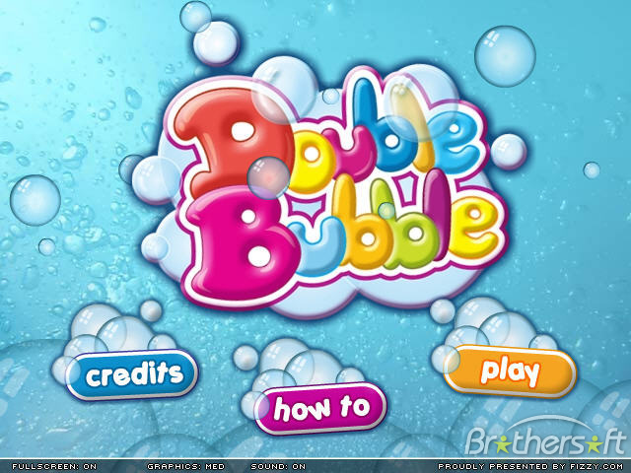



1. App Icon ( similar to above)
2. Menu screen

* Play button
* Rate app button
* Settings Button
* Tutorial button
* High Score button
* Store Button
* FaceBook button
* Twitter Button
* Background

(Something similar to this screen)

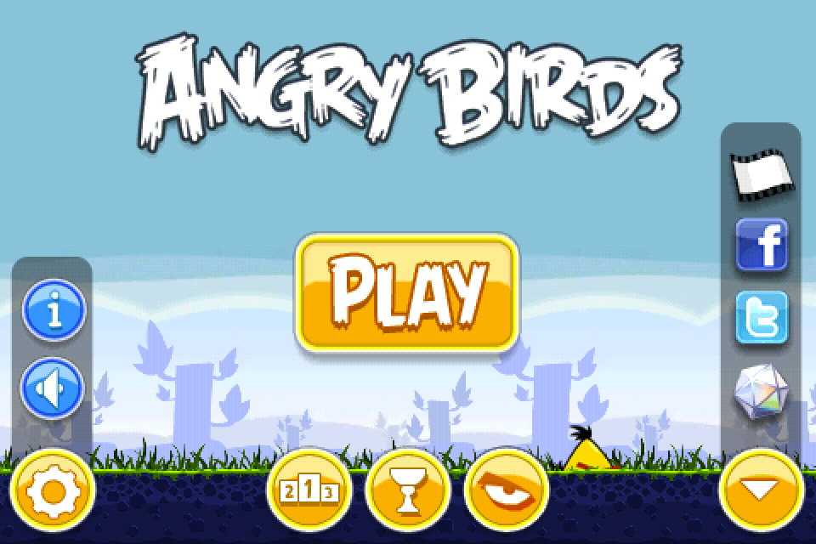

1. Settings Overlay

* Settings label image
* Music On/Off
* Sound On/Off
* Remove Ads Button
* Restore Purchase Button
* Close Button
* Overlay Background

(Something similar to this screen)

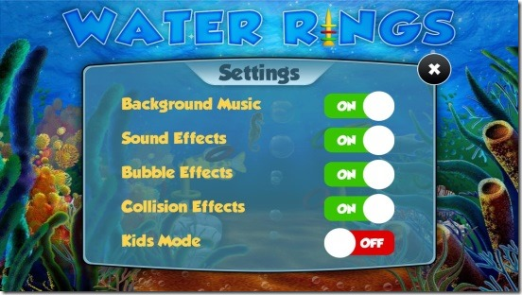

1. Main Game Screen

* Background Image
* POP title image
* Bubble Asset (already made)
* Shield Image
* Torpedo image
* Pause button

1. Pause Screen

* Play button
* Refresh game button
* Menu screen button
* Sound On/Off
* Music On/Off

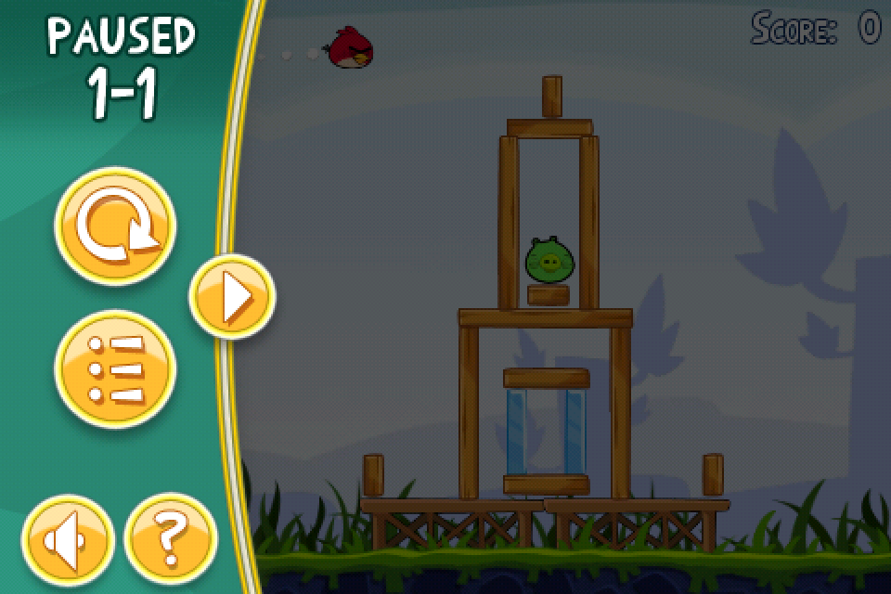

1. Game Over Screen

* Background Image
* Game over image
* Play again button
* Score label

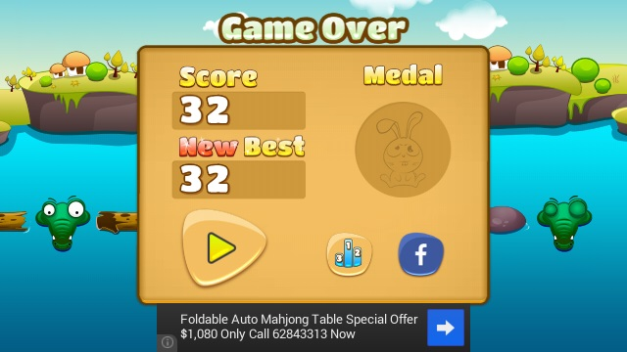

1. Store Screen

Tabbed Screen having two tabs power ups and coin packages

**Power Ups:**

* to slow down spawning of torpedoes
* to give bubble more life
* to change the color of shield
* to change the color of torpedoes

**Coin Packages:**

50 coins = .99 cents

150 coins = $1.99

500 coins = $2.99

1000 coins = $5.99

100, 000 coins = $99

